

**UNIVERSITI MALAYSIA TERENGGANU**

**CSM3103 – FRONT-END PROGRAMMING**

**BACHELOR OF COMPUTER SCIENCE (MOBILE COMPUTING) WITH HONORS**

**LAB 4**

**SEMESTER II 2023/2024**

**Prepared for:**

DR RABIEI BIN MAMAT

**Prepared by:**

MUHAMMAD ARIF HAIKAL BIN SALLEHUDDIN

(S66355)

**Link Github :**

[**https://github.com/arifhaikal2001/CSM3103-LAB-4.git**](https://github.com/arifhaikal2001/CSM3103-LAB-4.git)

**Task 1 – JavaScript Function**

Code :

Html

|  |
| --- |
| <!DOCTYPE html>  <html lang="en">  <head>  <meta charset="UTF-8">  <meta name="viewport" content="width=device-width, initial-scale=1.0">  <title>Task 1</title>  <script src="Task 1.js" defer></script>  </head>  <body>  <h1> JavaScript Function</h1>  <div id="output"></div>    <button onclick="findSquare()">Find Square</button>  <button onclick="sumOfCubes()">Sum of Cubes</button>  <button onclick="reverseNumber()">Reverse Number</button>  <button onclick="divisibleByZ(parseInt(prompt('Enter a number to find divisible numbers between 1 and 100:')))">Divisible Numbers</button>  </body>  </html> |

Js

|  |
| --- |
| function findSquare() {  let number = parseInt(prompt("Enter a number to find its square:"));  let square = number * number;  document.getElementById("output").innerText = `Square of ${number} is: ${square}`;  }  function sumOfCubes() {  let num1 = parseInt(prompt("Enter the first number:"));  let num2 = parseInt(prompt("Enter the second number:"));  let sum = Math.pow(num1, 3) + Math.pow(num2, 3);  document.getElementById("output").innerText = `Sum of cubes of ${num1} and ${num2} is: ${sum}`;  }  function reverseNumber() {  let number = parseInt(prompt("Enter a number to reverse:"));  let reversed = 0;  while (number > 0) {  reversed = (reversed * 10) + (number % 10);  number = Math.floor(number / 10);  }  document.getElementById("output").innerText = `Reversed number is: ${reversed}`;  }  function divisibleByZ(z) {  let output = "";  for (let i = 1; i <= 100; i++) {  if (i % z === 0) {  output += i + ", ";  }  }  document.getElementById("output").innerText = `Numbers between 1 and 100 divisible by ${z} are: ${output}`;  } |

Output :

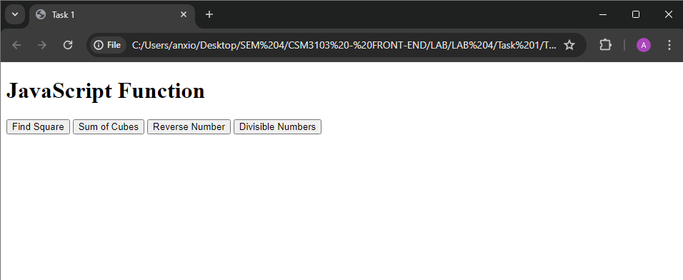

* Find Square

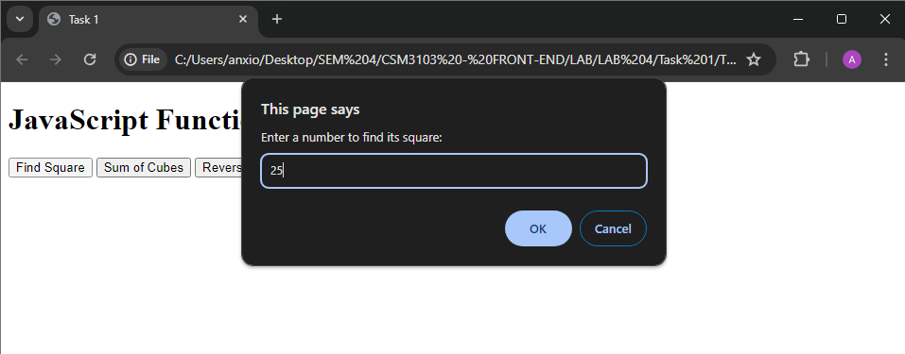

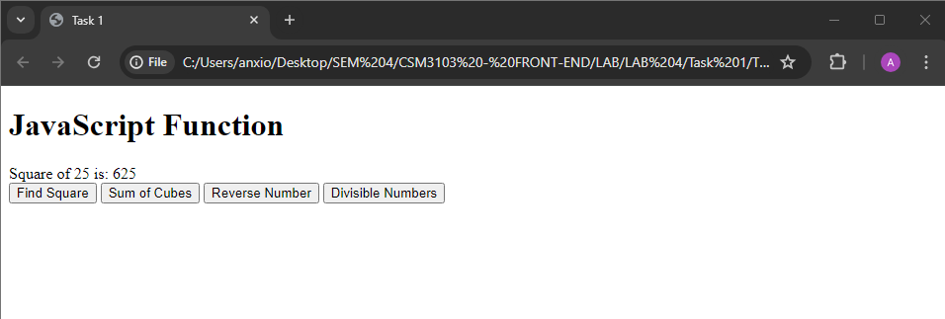

* Sum of Cubes

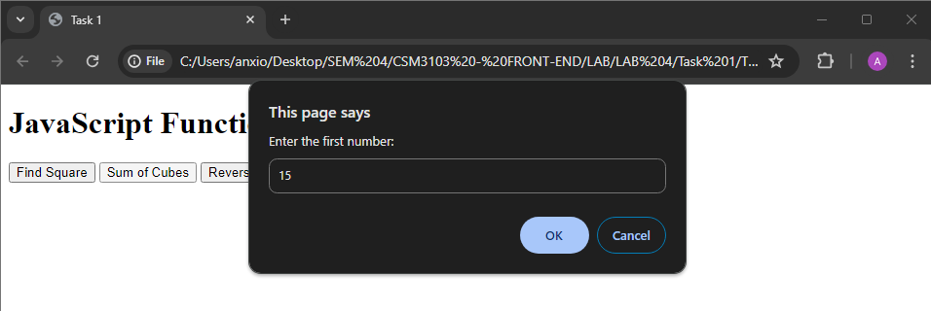

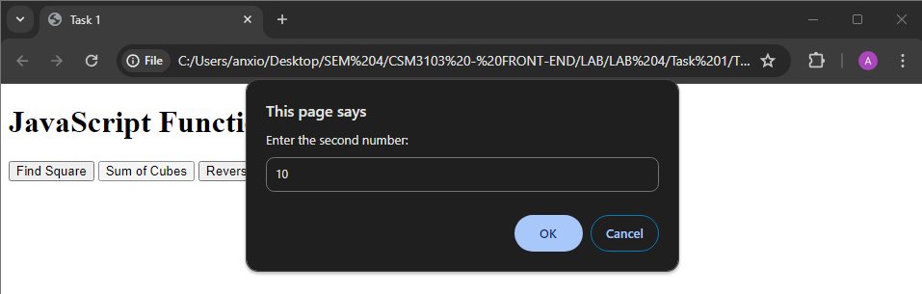

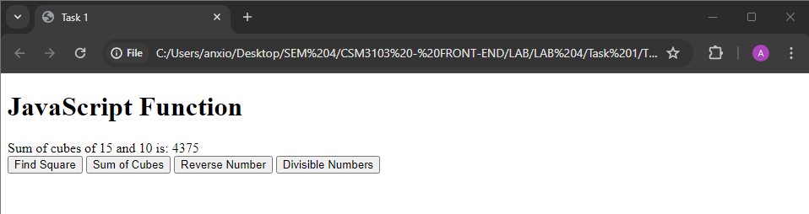

* Reverse Number

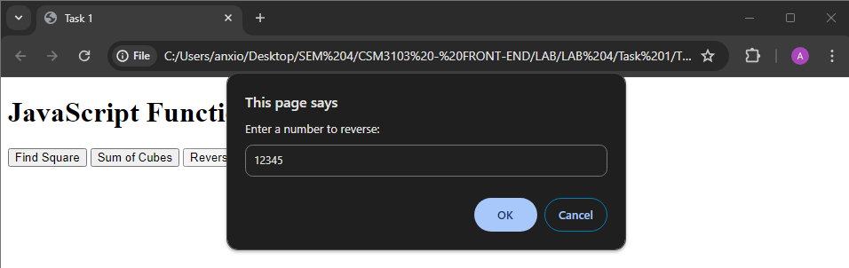

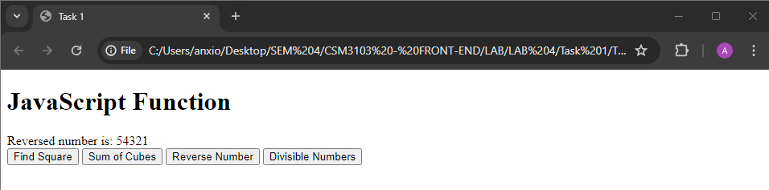

* Divisible Numbers

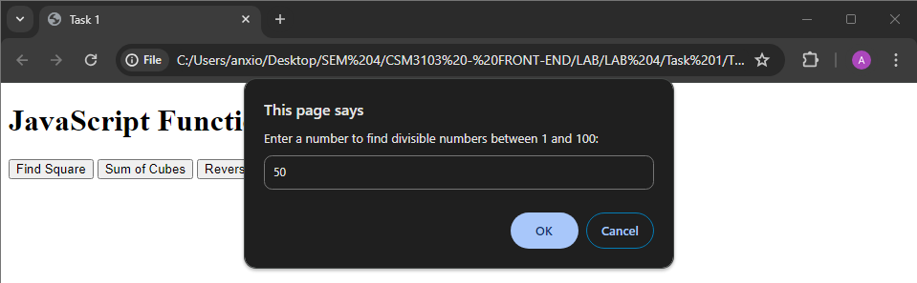

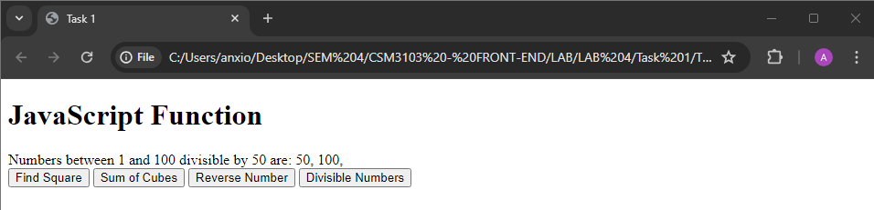

**Task 2 - JavaScript Recursion Function**

Code :

Html

|  |
| --- |
| <!DOCTYPE html>  <html lang="en">  <head>  <meta charset="UTF-8">  <meta name="viewport" content="width=device-width, initial-scale=1.0">  <title>Task 2</title>  <script src="Task 2.js" defer></script>  </head>  <body>  <h1>Recursion Functions</h1>  <div id="output"></div>  <button onclick="sumOfDigits()">Sum of Digits</button>  <button onclick="power(parseInt(prompt('Enter base:')), parseInt(prompt('Enter exponent:')))">Power</button>  </body>  </html> |

Js

|  |
| --- |
| function sumOfDigits() {  let number = parseInt(prompt("Enter a number to find sum of its digits:"));  let sum = calculateSumOfDigits(number);  document.getElementById("output").innerText = `Sum of digits of ${number} is: ${sum}`;  }  function calculateSumOfDigits(number) {  if (number === 0) {  return 0;  } else {  return (number % 10) + calculateSumOfDigits(Math.floor(number / 10));  }  }  function power(x, y) {  let result = calculatePower(x, y);  document.getElementById("output").innerText = `${x} raised to the power ${y} is: ${result}`;  }  function calculatePower(x, y) {  if (y === 0) {  return 1;  } else if (y > 0) {  return x * calculatePower(x, y - 1);  } else {  return 1 / calculatePower(x, -y);  }  } |

Output :

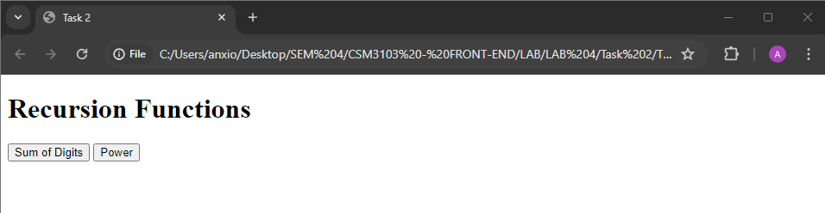

* Sum of digits

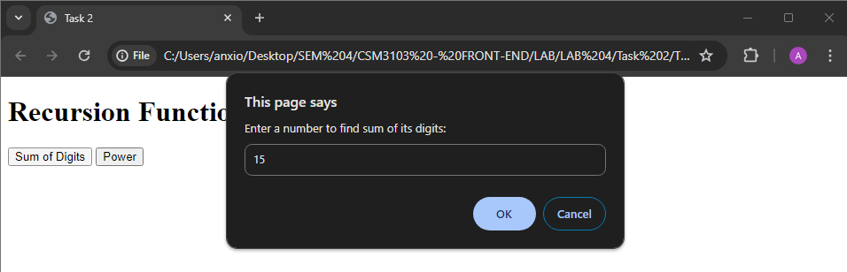

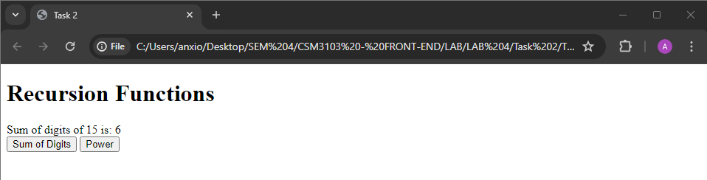

* Power

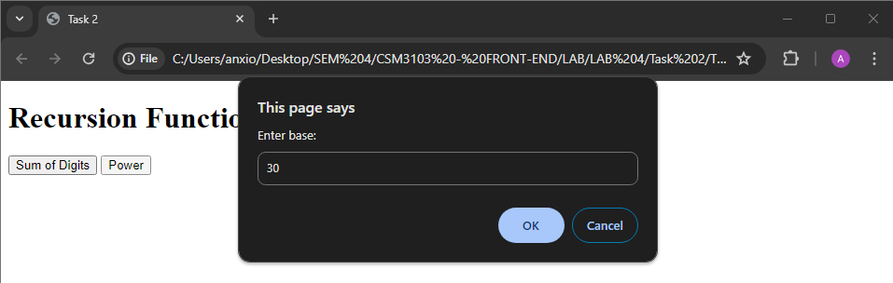

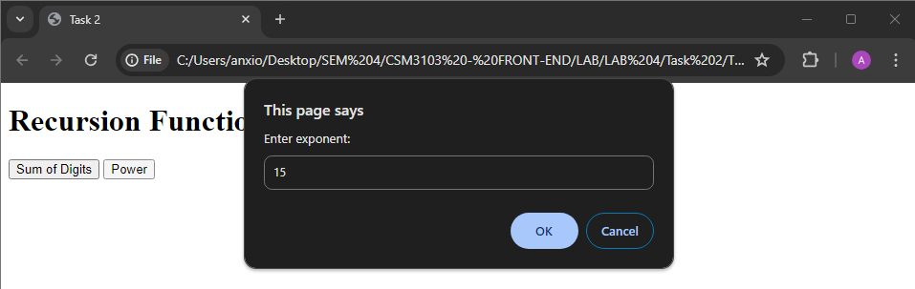

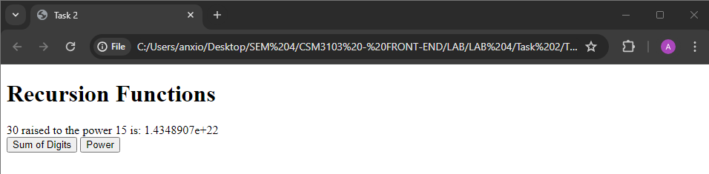

**Task 3 – JavaScript Object and Prototype**

Code :

Html

|  |
| --- |
| <!DOCTYPE html>  <html lang="en">  <head>  <meta charset="UTF-8">  <meta name="viewport" content="width=device-width, initial-scale=1.0">  <title>Task 3</title>  </head>  <body>  <h2>Product Details</h2>  <form id="productForm">  <label for="productName">Product Name:</label>  <input type="text" id="productName" required><br><br>  <label for="quantity">Quantity:</label>  <input type="number" id="quantity" required><br><br>  <label for="price">Price:</label>  <input type="number" id="price" required><br><br>  <button type="button" onclick="addProduct()">Add Product</button>  </form>  <h2>Book Details</h2>  <form id="bookForm">  <label for="bookName">Book Name:</label>  <input type="text" id="bookName" required><br><br>  <label for="authorName">Author Name:</label>  <input type="text" id="authorName" required><br><br>  <label for="bookPrice">Price:</label>  <input type="number" id="bookPrice" required><br><br>  <button type="button" onclick="addBook()">Add Book</button>  </form>  <h2>Output</h2>  <div id="output"></div>  <script src="Task 3.js"></script>  </body>  </html> |

Js

|  |
| --- |
| function Product(name, quantity, price) {  this.name = name;  this.quantity = quantity;  this.price = price;  }  function addProduct() {  const productName = document.getElementById('productName').value;  const quantity = parseInt(document.getElementById('quantity').value);  const price = parseFloat(document.getElementById('price').value);  const product = new Product(productName, quantity, price);  displayOutput(product);  }  function Book(bookName, authorName) {  this.bookName = bookName;  this.authorName = authorName;  }  Book.prototype.price = null;  function addBook() {  const bookName = document.getElementById('bookName').value;  const authorName = document.getElementById('authorName').value;  const bookPrice = parseFloat(document.getElementById('bookPrice').value);  const book = new Book(bookName, authorName);  book.price = bookPrice;  displayOutput(book);  }  function displayOutput(obj) {  let outputDiv = document.getElementById('output');  let outputHTML = '';  for (let prop in obj) {  if (obj.hasOwnProperty(prop)) {  outputHTML += `<strong>${prop}:</strong> ${obj[prop]}<br>`;  }  }  outputDiv.innerHTML += outputHTML + '<br>';  } |

Output :

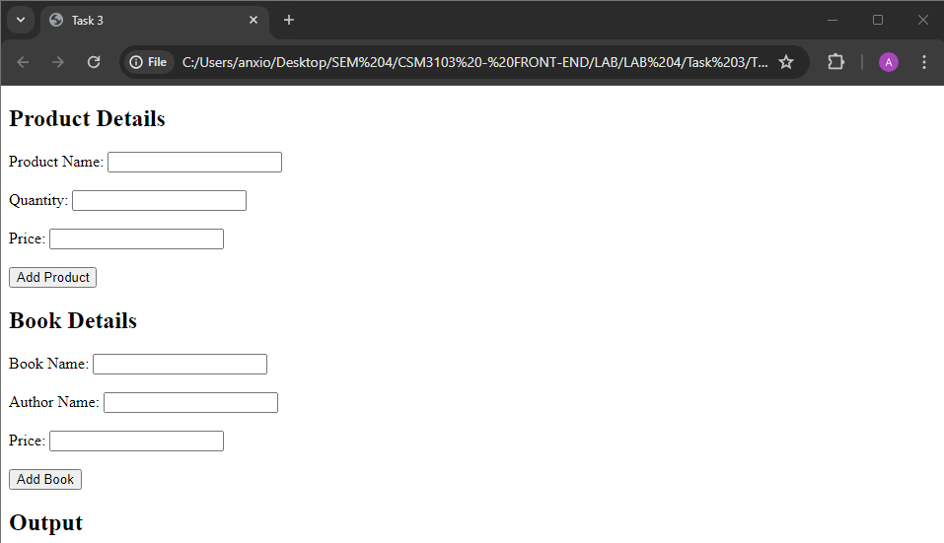

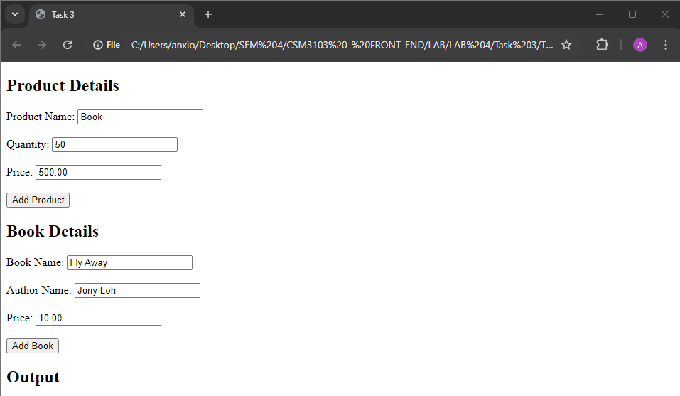

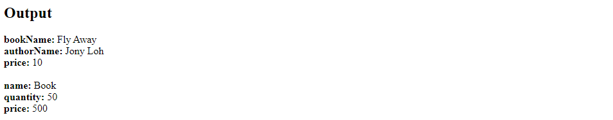

**Task 4 – Event Manager**

Code :

Html

|  |
| --- |
| <!DOCTYPE html>  <html lang="en">  <head>  <meta charset="UTF-8">  <meta name="viewport" content="width=device-width, initial-scale=1.0">  <title>Task 4</title>  <style>  #paragraph {  padding: 20px;  border: 1px solid black;  cursor: pointer;  }  #textfield {  padding: 10px;  font-size: 16px;  transition: all 0.3s ease;  }  </style>  </head>  <body>  <h1>Number 1 - Change the paragraph color</h1>  <p id="paragraph">Click me!</p>  <h1>Number 2 - Text Field Events</h1>  <input type="text" id="textfield" placeholder="Type something...">  <script src="eventmanager.js"></script>  <script src="textfield.js"></script>  </body>  </html> |

Js (eventmanager)

|  |
| --- |
| const paragraph = document.getElementById('paragraph');  paragraph.onclick = function() {  paragraph.style.backgroundColor = 'yellow';  };  paragraph.ondblclick = function() {  paragraph.style.backgroundColor = 'blue';  };  paragraph.onmouseover = function() {  paragraph.style.backgroundColor = 'red';  };  paragraph.onmouseout = function() {  paragraph.style.backgroundColor = 'green';  }; |

Js (textfield)

|  |
| --- |
| const textfield = document.getElementById('textfield');  textfield.onchange = function() {  textfield.style.border = '2px solid blue';  };  textfield.onfocus = function() {  textfield.style.backgroundColor = '#f0f0f0';  };  textfield.onblur = function() {  textfield.style.backgroundColor = 'white';  }; |

Output :

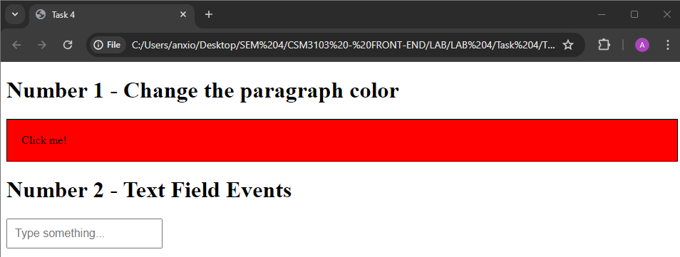

**Task 5**

Code :

Html

|  |
| --- |
| <!DOCTYPE html>  <html lang="en">  <head>  <meta charset="UTF-8">  <meta name="viewport" content="width=device-width, initial-scale=1.0">  <title>Task 5</title>  </head>  <body>  <h2>Dynamic Table</h2>  <table id="myTable" border="1">  <thead>  <tr>  <th>#</th>  <th>Name</th>  <th>Email</th>  <th>Phone</th>  </tr>  </thead>  <tbody>  </tbody>  </table>  <br>  <input type="text" id="name" placeholder="Enter Name">  <input type="text" id="email" placeholder="Enter Email">  <input type="text" id="phone" placeholder="Enter Phone">  <button onclick="addRow()">Add Record</button>  <script src="Task 5.js"></script>  </body>  </html> |

Js

|  |
| --- |
| function addRow() {  var table = document.getElementById("myTable").getElementsByTagName('tbody')[0];  var newRow = table.insertRow(table.rows.length);  var cells = [];  for (var i = 0; i < 4; i++) {  cells.push(newRow.insertCell(i));  }  cells[0].innerHTML = table.rows.length;  cells[1].innerHTML = document.getElementById("name").value;  cells[2].innerHTML = document.getElementById("email").value;  cells[3].innerHTML = document.getElementById("phone").value;    document.getElementById("name").value = "";  document.getElementById("email").value = "";  document.getElementById("phone").value = "";  }  window.onload = function() {  var table = document.getElementById("myTable");  var header = table.createTHead();  var row = header.insertRow(0);  var headerCells = [];  for (var i = 0; i < headerCells.length; i++) {  var cell = row.insertCell(i);  cell.innerHTML = headerCells[i];  }  }  document.addEventListener('DOMContentLoaded', function() {  var table = document.getElementById("myTable");  table.onclick = function(e) {  if (e.target.tagName.toLowerCase() === 'td') {  var index = e.target.parentNode.rowIndex;  table.deleteRow(index);  }  };  }); |

Output :

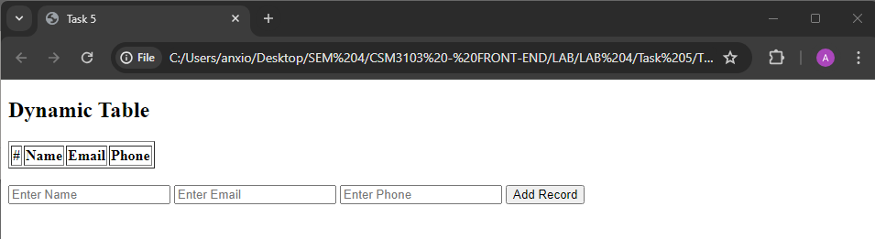

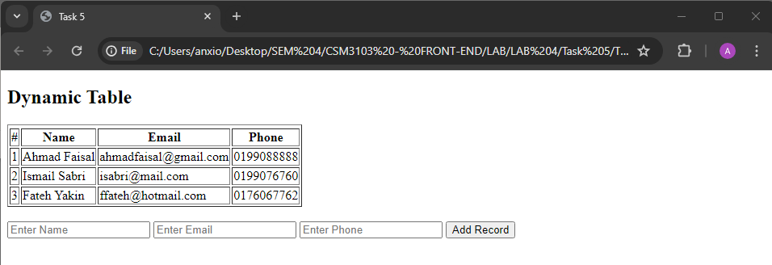

**Task 6**

Code :

Html

|  |
| --- |
| <!DOCTYPE html>  <html lang="en">  <head>  <meta charset="UTF-8">  <meta name="viewport" content="width=device-width, initial-scale=1.0">  <title>Task 6</title>  <style>  #container {  position: relative;  width: 400px;  height: 400px;  border: 2px solid black;  }  .small-square {  position: absolute;  width: 20px;  height: 20px;  background-color: red;  }  </style>  </head>  <body>  <div id="container">  <div id="square1" class="small-square"></div>  <div id="square2" class="small-square"></div>  </div>  <button id="startBtn">Start Animation</button>  <button id="stopBtn">Stop Animation</button>  <script src="Task 6.js"></script>  </body>  </html> |

Js

|  |
| --- |
| let intervalId;  function moveSquares() {  const container = document.getElementById('container');  const square1 = document.getElementById('square1');  const square2 = document.getElementById('square2');  const containerWidth = container.clientWidth;  const containerHeight = container.clientHeight;  const squareWidth = square1.clientWidth;  const squareHeight = square1.clientHeight;  intervalId = setInterval(() => {  const randomX1 = Math.floor(Math.random() * (containerWidth - squareWidth));  const randomY1 = Math.floor(Math.random() * (containerHeight - squareHeight));  const randomX2 = Math.floor(Math.random() * (containerWidth - squareWidth));  const randomY2 = Math.floor(Math.random() * (containerHeight - squareHeight));  square1.style.left = randomX1 + 'px';  square1.style.top = randomY1 + 'px';  square2.style.left = randomX2 + 'px';  square2.style.top = randomY2 + 'px';  }, 1000);  }  function stopAnimation() {  clearInterval(intervalId);  }  document.getElementById('startBtn').addEventListener('click', moveSquares);  document.getElementById('stopBtn').addEventListener('click', stopAnimation); |

Output :

